Space-Y

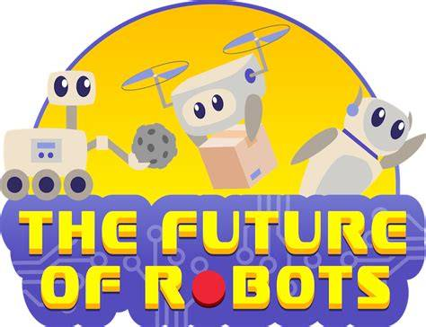

The Unknown Team

Ahmed Bin Hanbal School

WRO  
2025-2026

Table of Contents

Team Members 4

Summary of Project Idea 5

Presenting the Robotic Solution 6

Introduction to the Robotic Solution 6

Evolution of the Project Idea 6

Research into Similar Solutions 7

Prototype Design and Mechanical Construction 7

Orbital Model and Satellite Representation 7

The Robotic System 8

Recycling Device 8

Prototype Photos and Diagrams 8

Coding and Software Architecture 8

Autonomous Navigation 9

Task Execution and Decision Making 9

Communication and Monitoring 9

Code Structure 9

Challenges Faced During Development 9

Simulating Orbital Conditions 10

Integrating Multiple Functions 10

Recycling Device Engineering 10

Coding Constraints 10

Social Impact & Innovation 10

Impact of Our Solution on Society 10

Reducing Space Debris and Increasing Safety 11

Extending Satellite Lifespan and Serviceability 11

Promoting a Circular Economy in Space 11

Environmental Benefits on Earth 11

Who Will It Help and How Important Is It? 12

Concrete Use Case: Satellite Servicing for a Global 13

Communications Network 13

Problem Scenario 13

Space-y’s Role 13

Benefits and Scale of Impact 13

Broader Societal Implications and Innovation 14

Possible Negative Effects and Mitigation 14

# Team Members

We are **Space-y Explorers**, a team of four students passionate about robotics, space, and sustainability. Each of us played a key role in bringing our idea to life.

**Mostafa Aboshosha** was the **Lead Designer**, responsible for the structure and mechanical design of the robot. They worked on the arm mechanisms, recycling system, and overall layout of the robot to make sure it could perform its tasks in orbit.

**Mostafa Aboshosha** took on the role of **Programmer**. They developed the code that controls the robot’s behavior, including how it identifies satellites, approaches them, and decides whether to refuel, repair, or recycle.

**Mostafa Aboshosha** was the **Research Lead**. They studied real-world technologies and missions related to satellite servicing, space debris, and 3D-printing in orbit. This research helped us understand what is possible and inspired many features of our project.

**Mostafa Aboshosha** served as the **Project Manager**, organizing our timeline, dividing responsibilities, and making sure everything—from our robot to the report—was completed on time. They also worked on creating the website that tracks satellite status and robot activities.

## Summary of Project Idea

The increasing number of satellites orbiting Earth has brought many benefits, including improved communication, navigation, weather forecasting, and scientific research. However, this growth also causes a serious problem: space debris. Defunct satellites and fragments crowd Earth’s orbit, increasing collision risks that threaten active satellites and future space missions. Additionally, satellites often run out of fuel or suffer minor damage before the end of their expected life, leading to costly replacements and more debris.

Our project, **Space-Y**, is designed to tackle these challenges by deploying an autonomous robot in orbit that refuels, maintains, and recycles satellites. Space-Y’s main functions are:

* Refueling active satellites to extend their operational lifespan
* Performing maintenance and minor repairs to improve satellite reliability
* Recycling defunct satellites by extracting plastics and converting them into 3D-printing filament for in-orbit manufacturing

By refueling satellites and repairing minor damages, Space-Y reduces the need to launch new satellites, which lowers costs and decreases the environmental impact of rocket launches. Recycling plastic parts from old satellites supports a circular economy in space, reducing waste and creating new materials for manufacturing parts directly in orbit.

The value of Space-y lies in its potential to reduce space debris, extend satellite lifetimes, and promote sustainability in space operations. Additionally, we developed a website that tracks satellites’ locations and statuses in real time, providing accessible information for satellite operators, researchers, and the public.

If implemented in real life, Space-y would help protect vital satellite infrastructure, reduce space congestion, and encourage responsible use of Earth’s orbit — a limited and valuable resource. Our project is important because it offers an innovative, practical solution to both environmental and technological challenges facing the space industry today.

# Presenting the Robotic Solution

## Introduction to the Robotic Solution

Our project, **Space-y**, addresses the increasing problem of space debris and satellite lifespan limitations by developing an autonomous robotic system that orbits Earth to refuel, maintain, and recycle satellites. The idea of combining these three key functions—servicing active satellites and recycling defunct ones—into one robotic solution is innovative and essential for sustainable space operations. By refueling satellites, Space-y prolongs their mission life; through maintenance, it prevents premature failures; and by recycling obsolete satellites, it reduces space junk and repurposes valuable materials. This integrated approach not only enhances the safety and efficiency of space infrastructure but also promotes a circular economy in orbit.

## Evolution of the Project Idea

The idea originated from our concern about space debris and satellite sustainability. Initially, we explored multiple independent concepts: robots designed solely for refueling, debris capture devices, and in-orbit recycling systems. However, each concept alone seemed insufficient to fully address the challenges faced by satellite operators and space agencies.

During brainstorming sessions, we realized that combining these functions into a single system could maximize impact. We envisioned a robot capable of autonomously moving between satellites and orbit levels, determining their condition, and executing the appropriate task—whether refueling, repairing, or recycling.

LEGO robotics kits were chosen as the prototyping platform due to their accessibility, versatility, and ease of programming, which allowed rapid prototyping of complex robotic movements and interactions, facilitating practical demonstration of our concept. We also used other parts for the orbit and filament recycling station……………………….

## Research into Similar Solutions

In researching existing projects, we studied NASA’s Restore-L mission, which focuses on satellite refueling, and ESA’s e.Deorbit initiative, aimed at debris removal. These missions showcase the feasibility and importance of satellite servicing.

However, unlike these projects, Space-y integrates three critical functions: refueling, maintenance, and recycling, and a web-based system to track the location and status of any satellite. Particularly, the recycling feature—which converts plastics from obsolete satellites into 3D-printing filament—is a novel addition not commonly seen in current efforts. This approach addresses the growing problem of space debris while enabling resource reuse in orbit, advancing the concept of a sustainable space economy.

## Prototype Design and Mechanical Construction

### Orbital Model and Satellite Representation

Our prototype models Earth’s orbit as three concentric levels, each representing satellites in different conditions:

* The **first level** holds active satellites needing refueling.
* The **second level** contains satellites requiring maintenance due to mechanical issues.
* The **third level** has an out-of-service satellite that’ll be recycled at the recycling station.

Each level contains LEGO-built satellites, each programmed with a specific flaw that corresponds to its servicing need. The LEGO robot moves autonomously between these levels to perform its tasks.

### The Robotic System

The core of our prototype is a LEGO Mindstorms robot equipped with motors and sensors. The robot features:

* **Robotic arms** that are capable of grasping and interacting with the LEGO satellites to simulate refueling or maintenance.
* **Mobility systems** that allow it to travel vertically and horizontally between orbit levels, representing movement in space.
* **Sensors** that detect satellite movement to help with precise movement and maintenance.

The design ensures modularity and precision, allowing the robot to handle different satellite models and tasks.

### Recycling Device

To demonstrate our recycling process, we built a small plastic recycling device capable of melting plastic and extruding it as 3D-printing filament. The device includes:

* A heating element to melt plastic pellets sourced from old LEGO parts (symbolizing satellite plastic waste).
* An extrusion nozzle to shape molten plastic into consistent filament strands.
* A cooling mechanism to solidify the filament for use in 3D printing.

This device illustrates how Space-Y could recycle plastic components from defunct satellites and repurpose the material for manufacturing new parts directly in orbit.

### Prototype Photos and Diagrams

*Mechanical drawing of the recycling device

*Final 3D model of the recycling device

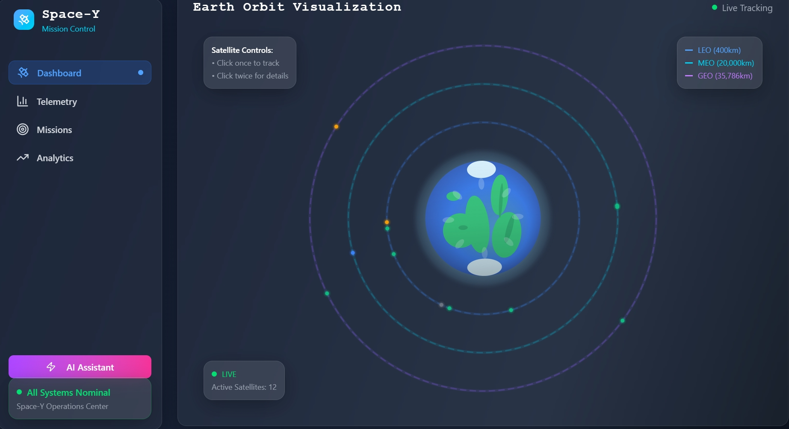

## *Screenshot of the web-based interface designed for tracking all components of the system

## Coding and Software Architecture

The robot is programmed using LEGO Mindstorms software for the orbiting robots combined with Python scripts to allow advanced control and decision-making, and optimizing the recycling process.

### Autonomous Navigation

The robot uses sensor inputs to navigate between orbital levels safely. It employs path-finding algorithms to:

* Identify the next satellite service.
* Move vertically or horizontally between orbit levels.
* Dock precisely with the satellite to begin operations.

### Task Execution and Decision Making

The robot’s onboard program assesses each satellite’s condition by reading preset status flags:

* If a satellite is low on fuel, the robot activates its refueling routine.
* If mechanical maintenance is required, the robot engages its repair arms to simulate fixing the satellite.
* For defunct or out-of-service satellites, the robot disassembles and recycles all the recyclable parts of the satellite.

### Communication and Monitoring

The system transmits servicing data, satellite status, and recycling outputs to a web interface for real-time tracking. This helps satellite operators and researchers monitor satellite health and manage space assets efficiently.

### Code Structure

* The main control loop governs navigation and task scheduling.
* Subroutines handle specific tasks like refueling and recycling.
* Error handling routines ensure safe operations and recovery from unexpected events.

[Insert flowchart of software logic]  
[Insert code snippets illustrating key functions]

## Challenges Faced During Development

### Integrating Multiple Functions

Combining refueling, maintenance, and recycling tasks within one robot required careful mechanical and software design to avoid conflicts and ensure smooth operation.

### Recycling Device Engineering

Designing a functional recycling device capable of melting and extruding filament at a small scale was technically demanding. We experimented with heating elements, extrusion speeds, and cooling methods to produce usable filament.

### Coding Constraints

Programming complex autonomous behaviors on the LEGO Mindstorms platform, which has limited processing power, challenged us to write efficient and robust code.

# Social Impact & Innovation

## Impact of Our Solution on Society

The Space-Y project addresses several critical challenges facing our global society in the era of increasing space activities. As humanity’s reliance on satellites grows, from communication and navigation to environmental monitoring and scientific research, ensuring the sustainability and reliability of these space assets is paramount.

### Reducing Space Debris and Increasing Safety

One of the most pressing issues in modern space exploration is the accumulation of space debris. Thousands of defunct satellites and fragments orbit Earth, posing collision risks to operational satellites, space stations, and future missions. Space-y’s ability to recycle defunct satellites and safely relocate them to a satellite graveyard helps mitigate this hazard. By reducing debris, our solution safeguards current and future space operations, which in turn protects the critical infrastructure that modern society depends on.

### Extending Satellite Lifespan and Serviceability

Satellites are expensive and resource-intensive to build and launch. Fuel limitations and mechanical wear typically limit their operational lifespan. Space-y’s refueling and maintenance capabilities can extend satellites’ service periods, reducing the need for frequent satellite replacements. This saves financial resources for satellite operators and reduces the environmental footprint of satellite manufacturing and launches.

### Promoting a Circular Economy in Space

The recycling feature of Space-y transforms obsolete satellite materials, specifically plastics, into 3D-printing filament for manufacturing new components. This promotes a circular economy model in space, encouraging sustainable use of resources. By turning waste into valuable raw material, Space-y supports the future vision of space habitats and in-orbit manufacturing, which could drastically reduce reliance on Earth-based supply chains.

### Environmental Benefits on Earth

By extending satellite lifespans and reducing launch frequency, Space-y indirectly contributes to decreasing the environmental impact associated with rocket launches, which include greenhouse gas emissions and atmospheric disturbances. Moreover, the recycling technology developed for space could inspire advancements in Earth-based recycling and manufacturing systems, driving innovations in sustainability.

## Who Will It Help and How Important Is It?

**1-Satellite Operators and Space Agencies**

The primary beneficiaries of Space-y are satellite operators, including commercial companies, telecommunications providers, scientific organizations, and governmental space agencies like NASA, ESA, and private space firms. These entities will gain:

* **Cost Savings:** By extending satellite life and avoiding premature replacement.
* **Improved Reliability:** Through routine maintenance and early problem detection.
* **Operational Safety:** Through debris reduction and collision prevention.

**2-The Global Population**

Indirectly, billions of people worldwide benefit from more reliable satellite services that Space-y supports. Satellites provide vital services such as GPS navigation, global communications, weather forecasting, disaster monitoring, and scientific data collection.

* **Emergency Response:** More reliable satellites enhance disaster warning systems, helping communities prepare for hurricanes, earthquakes, and floods.
* **Global Communication:** Improved satellite maintenance ensures uninterrupted internet, TV, and phone services even in remote areas.
* **Scientific Advancements:** Sustained satellite missions enable better climate monitoring and space research, contributing to global knowledge and policy decisions.

**3-The Environment and Future Generations**

By addressing space debris and promoting sustainable resource use, Space-y benefits the environment both in space and on Earth, ensuring that future generations inherit a safer orbital environment and a healthier planet.

## Concrete Use Case: Satellite Servicing for a Global

### Case: Communications Network

Consider a global satellite communications company managing a constellation of hundreds of satellites providing internet access worldwide. This company faces challenges such as satellite fuel depletion, minor malfunctions, and the increasing threat of space debris.

### Problem Scenario

Without servicing, many satellites reach end-of-life prematurely, disrupting connectivity in underserved regions. Additionally, defunct satellites clutter the orbital paths, increasing collision risk and potential service interruptions.

### Space-Y’s Role

* **Routine Refueling:** Space-y autonomously visits satellites low on fuel, refilling them to extend their operational periods without costly replacements.
* **Maintenance:** When satellites show signs of wear or minor technical issues, Space-y performs repairs, preventing mission failures.
* **Recycling:** Satellites that have truly reached end-of-life are moved to the satellite graveyard. Space-y recycles their plastic components into filament, which can be used to 3D print replacement parts for other satellites or space infrastructure.

### Benefits and Scale of Impact

* **Continuous Connectivity:** The satellite operator maintains uninterrupted service for millions of users globally, including remote communities relying on satellite internet.
* **Cost Efficiency:** The company saves millions annually by reducing the need for new satellites and launch costs.
* **Reduced Space Debris:** The satellite graveyard and recycling system significantly lower collision risks and long-term orbital pollution.
* **Technology Advancement:** Filament recycling fosters in-orbit manufacturing, opening new possibilities for satellite repairs and customizations without returning to Earth.

### Broader Societal Implications and Innovation

**1-Encouraging Space Sustainability**

Space-y promotes sustainable practices in space exploration—a growing concern as private and public space missions multiply. It embodies the principles of responsible use of space, resource efficiency, and debris mitigation, aligning with international guidelines and fostering collaboration among spacefaring nations.

**2-Inspiring STEM Education and Innovation**

The LEGO-based prototype and recycling device provide an educational platform inspiring young people to explore robotics, environmental science, and space technologies. This can cultivate the next generation of engineers and scientists dedicated to sustainable space exploration.

**3-Economic Opportunities**

By enabling in-orbit recycling and manufacturing, Space-y paves the way for new space-based industries, potentially creating jobs and business ventures in space logistics, recycling technology, and robotic servicing.